1) create table new(emp_id number(10) , emp_name varchar2(10) , hire_data date , salary number(10))

2) desc new;

## Altering the table

## Adding a new field to the table

alter table <table_name> add <column_name> datatype(size)

"alter table new add emp_age number(10)"

varchar2 --> Dynamic allocation

varchar --> Static allocation

**# Modifying the memory of a specific column**

alter table <table_name> modify <column_name> data-type(size)

"alter table new modify address varchar2(30)"

**# Deleting a specific attribute**

alter table <table_name> delete column <attribute_name>

alter table <table_name> drop column <attribute_name>

"alter table new delete column address"

**# Inserting a particular attribute into a table**

alter table <table_name> add <attribute_name> data-type(size)

**# Entering the data into that added attribute**

insert all

2 into <table_name> <newly_added_column> values (desired values)

3 into <table_name> <newly_added_column> values (desired values)

select * from dual

# Rename a specific attribute name

alter table <table_name> rename column <old_attribute_name> to <new_atrribute_name>

"alter table new rename column emp_id to emp_number"

# Rename the table name

rename <old_table_name> to <new_table_name>;

"rename new to prashanth"

# Inserting a record into the data-set

insert into <table_name> values(records)

"insert into prashanth values(11188,'Kumar','12/august/97',100000)"

# Check whether the record is inserted/not

select * from <table_name>

"select * from prashanth"

# Deletes a record where the salary=50000

delete from <table_name> where <attribute_name> = '5000'

"delete from Prashanth where salary='50000' "

## Delete a particular row

delete

from

<table_name>

where

<column_name> = <Particular row's column name>

**## Truncating the table**

All the data's will be deleted only the structure of the table will be retained

truncate table <table_name>

"truncate table Prashanth"

## What are all the constraints in a table???

select constraint_name,constraint_type from user_constraints where table_name = '<table_name>';

**## Alligning the page**

set linesize 200;

set pagesize 400;

**## Adding the date to the required format in a table**

insert into sample values('Mothish',TO_DATE('2001/10/05','yyyy/mm/dd'));

**## Calculating the age from the table**

select EXTRACT(YEAR FROM sysdate) - EXTRACT(YEAR FROM to_date(<date of birth attribute name>, 'DD-MON-YYYY')) as "Age" from <table_name>

## inserting the values to a specific row

**##Adding the Constraints to a table**

**Primary key constraint**alter table <table_name> add constraint <constraint_name> primary key(attribute which you want to set as a primary key);

**Not-NULL constraint**alter table <table_name> add constraint <constraint_name> CHECK (<attribute_name> IS NOT NULL);

**Foreign key constraint:**

Table-1 (sample-1) [emp_id,emp_name]  
Table-2 (sample-2) [cust_id , cust_name , emp_id]

alter table sample-2 add constraint emp_if_fk   
foreign key(emp_id) references sample-1(emp_id) on delete set null;

alter table <table_name> add constraint <constraint-name>  
foreign key (<attribute_name>) references <table_name>(<attribute_name>) on delete set null;

**Check constraint:**

alter table <table_name> add constraint <constraint_name> check(<attribute_name> in(condition in the constraint));

alter table sample-1 add constraint emp_name_ck check(emp_name in('X1','X2','X3','X4')); 🡪 This means that other than X1,X2,X3,X4 no other name should be entered.

**Unique constraint:**

alter table <table_name> add constraint <constraint_name> UNIQUE(<attribute_name>);

**## Checking what are all the constraints are in my table**

select constraint_name,constraint_type from user_constraints where table_name=<table name must be in caps>

**## Disabling the constraint**

alter table <table_name>  
DISABLE constraint <constraint_name>

**## Deleting the constraints**

ALTER TABLE <table_name> **DROP CONSTRAINT** <constraint_name>

**## To get the age from the date of birth**

select EXTRACT(YEAR FROM sysdate) - EXTRACT(YEAR FROM to_date(<date of birth-attribute name>, 'DD-MON-YYYY')) as "Age" from <table_name>;

**## Extracting the year from date of birth**

select extract (year from to_date(<attribute_name>,'DD-Mon-YYYY'))YEAR from <table_name>;

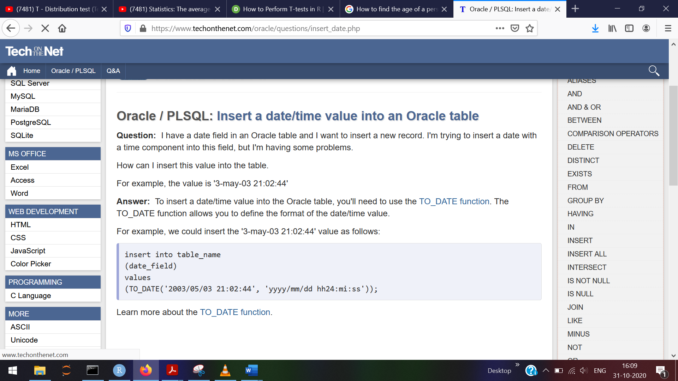

insert into sample values('Mothish',TO_DATE('2001/10/05','yyyy/mm/dd'));